Website Planning Document:

The Mountain Spoke

Motto: Cycling life on an uphill slope

Author: Jalyn Zamora

Site Purpose:

The purpose of this website is for the user to be able to clearly find anything bike related in the area. Whether it’s buying a new one, repairing an old one or just being interested. The website is to inform other about the many trails, events, and products.

Target Audience:

There will be a lot of people that will stumble upon the website. However, the website’s target audience are biking enthusiast, those looking for a new bike or bike repair and/or those who are interested in a new hobby. Most people visiting the site will be looking for a quick glance at products and prices, while others could be looking for biking events happening around the city or popular biking trails they can go on.

Site Map:

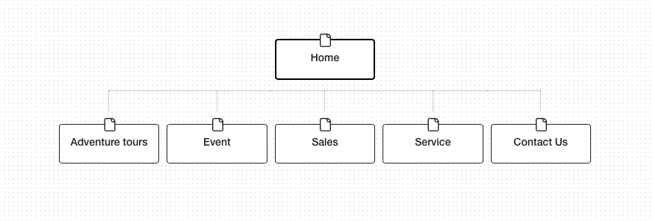

Color Scheme:

I chose this color scheme because I like the idea of having neutral colors for the website. The shades of green and blue give a hint of color to the website. I want the images on the website to pop, so have these simple yet appeal colors will bring the webpage to life.

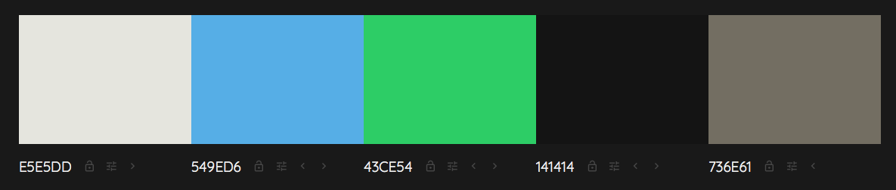

Typography:

For my titles and heading I’m going to use a sans serif type of font. I’ve added a couple of examples of the type of fonts I’m planning to use:

 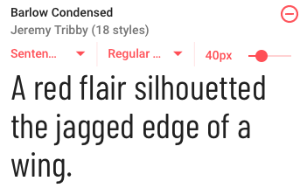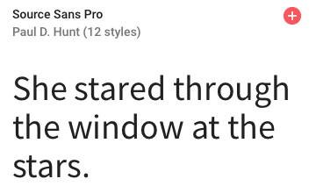

Wireframes:

Ipad, Desktop, Phone: <https://wireframe.cc/UXiPuI>

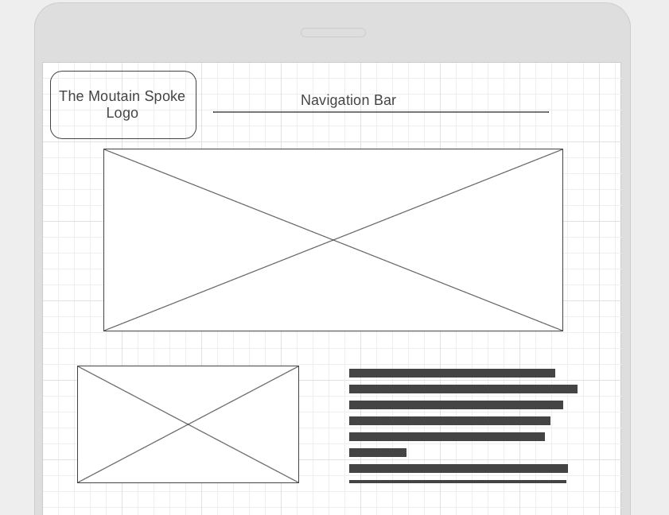

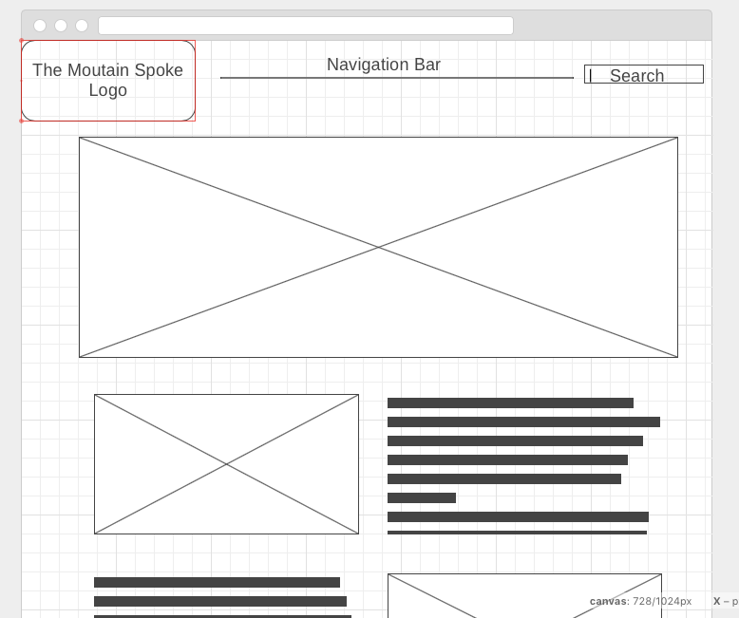

Final Website Project:

https://jalynzamora.github.io/cit230/assignments/term-website-project/index.html